Zion Evangelical Lutheran
13511 Roland Lake Road
Skanee, MI 49962

November-December 2019

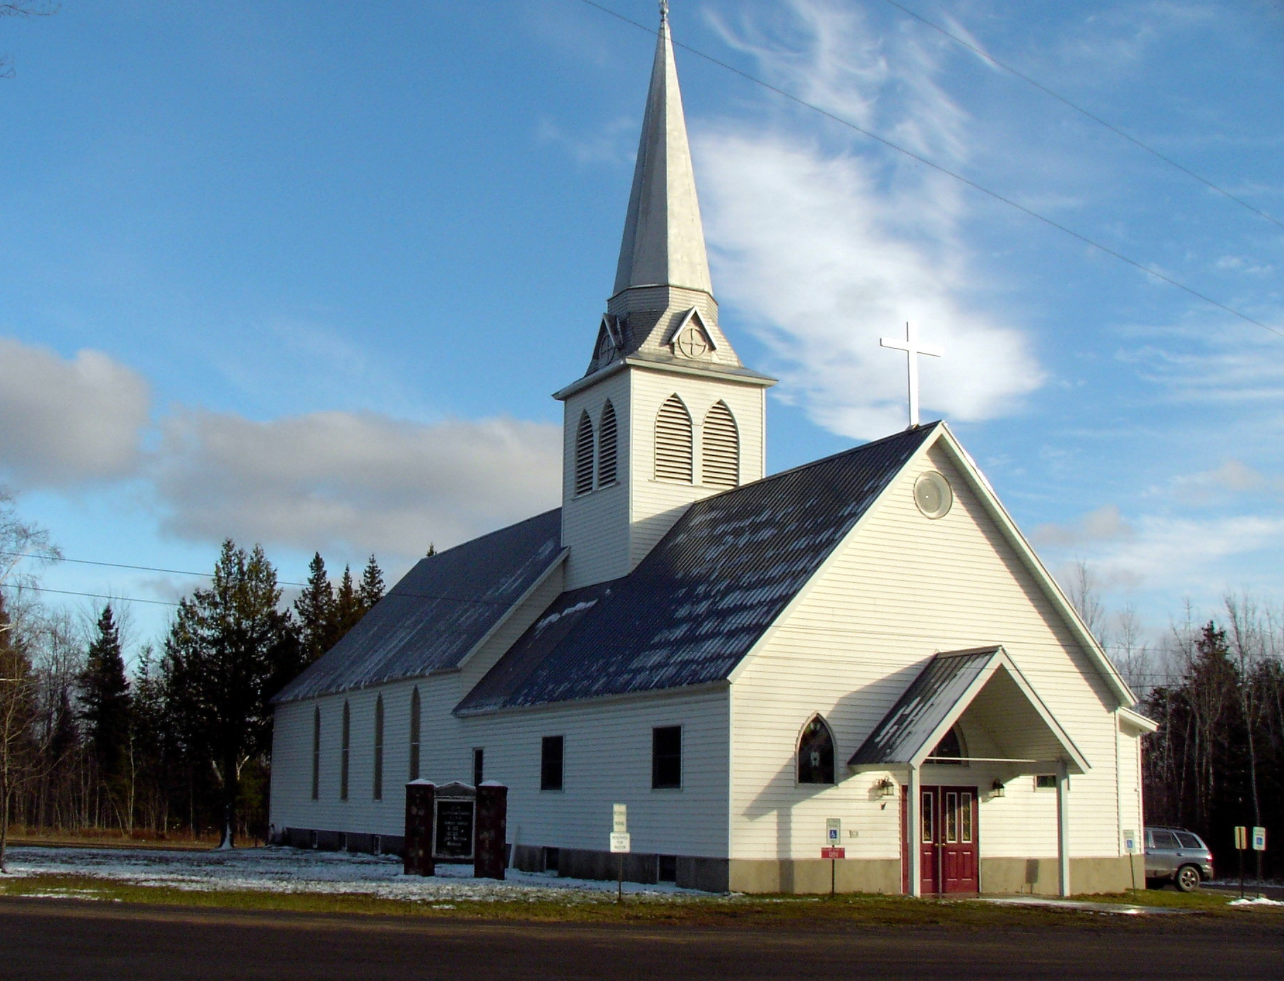

Zion Lutheran Church
13511 Roland Lake Road
Ph: 906-524-6524
Email: zionlutheranskanee@gmail.com
Website: www.zionlutheranskanee.org;

Pastor Rich Little
email: rich-little@excite.com
cell/text #: (906) 395-0886

.

Letter from the Pastor
“For in this hope we were saved. Now hope that is seen is not hope. For who hopes for what he sees? But if we hope for what we do not see, we wait for it with patience.” Romans 8:24-25
The fall leaves are almost all off the trees now. The final preparations for the Deer Camp are being finished. All are getting ready to brace the onslaught of another U.P. winter season. The months of November and December also are a time of seasonal change in the church, too.
On the church year calendar, we are ending the season of Pentecost on Sunday November 24th with the celebration of “Christ the King” Sunday which reminds us of the promise of the triumphant bodily return of our Lord Jesus Christ to us someday. We then immediately begin a new church year with the season of Advent (which begins December 1 this year). Advent season comprises the four weeks prior to the Festival of the Nativity (aka Christmas day and the season of Christmas). Both Christ the King Sunday and Advent have traditionally been a time of thought & reflection in the church on our hope. So, what is it that we hope for as baptized children of the Heavenly Father (aka Christians)?

Well, the larger modern world has pinned its hopes it seems only on material things. Our American culture in particular has done a great job of getting us to put our hope in the next great tech gadget. In our country the time before Christmas is filled with manic activity, much of it tied to the purchasing of gifts. Don’t get me wrong. I enjoy the customs of gift giving & Santa as much as anyone. But if these are the things that define our hope and its fulfillment, something is missing for we baptized Christians.
As the culture drives us relentlessly onward toward the next big things, Christ the King Sunday and the season of Advent do the opposite. They call us to slow down & take time to examine what it is we truly
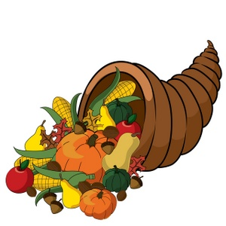

Readers for November

November 2 Paul Perry

November 10 Chuck Schroeder

November 16 Therese Korpi

November 24 Bertha Hommer

November 30 Beth Fish

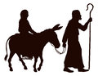

Readers for December

Please check bulletin board for December Readers

Merry Christmas

LET US PRAY…. (prayer is service to God and community)
Pat Carmody, Jim & Carol Cooley, Roger Griffin, Dianne Haapala, Glenda Hiltunen, Roger Jordan, Kathy Magnant, Theresa Pascoe, Dan Roth, Doris Roth, Lois Roth, Curt Royal, Clay VanBuren, Roger Wiik.
(Please take the time to visit our shut-ins – they are a part of our church family and need your prayers, your support, and your love)

All of our military personnel.
Congregations: Wainola Lutheran Church; Bethany Lutheran, Covington; Aura Lutheran; Kemi Lutheran Church, Russian Karelia.

(Please keep Lisa up-to-date on who should be added or removed on this list)
zionlutheranskanee@gmail.com

Family Emergencies, Hospitalizations, or Deaths
Please notify Pastor Rich or the church office when these events occur. Our goal as the body of Christ is to provide timely Pastoral Care, Prayer, or Presence in your time of crisis based upon your need.

Dear God, I humbly ask that you heal us from hurt, shame, sickness, and guilt. Heal our hearts, O Lord God. Give us beauty for ashes, the oil of joy for mourning, and let us wear the garment of praise instead of the spirit of heaviness and burden. I pray in Jesus name. Amen.

hope for. They are a time where we can ponder our year & ask ourselves if the balancing act we call “my life” is really working. You see, our tendency as sinners is to attach our hopes & dreams to stuff or even other people. Really, we all have a very bad track record in this regard. You and I quite quickly and easily make almost anything other than the God who has come to us in Jesus Christ our the object of our love and trust. So these two upcoming celebrations, like all the seasons of the church year, are meant to bring into sharper focus these realities of the life of faith that accompany us all year long.
The Bible texts we will be reading in Church for Christ the King Sunday and the Advent season reflect this great theme of human hope which is something so real yet often so tragically misplaced. These celebrations bring us a back to a reality of ourselves as sinners; as ones who are apt to misplace our hope. They remind us of how it really is with us. Of how we live for now under the sign of the Cross of Christ as we walk in the days of our baptism as simultaneously sinners and saints, frightened and fragile, longing for friendship and real faith and true love, understanding and forgiveness.
Truly, the hopes that anticipate their fulfillment in the coming of Jesus are best encountered at the Cross. In this regard, Christ the King Sunday and the season of Advent are what Luther once called “the little Lent” because they focus us on facing our deepest hopes. And to do so is to be brought, once again, to the foot of the Cross. There we encounter both our great need and our gracious, crucified Lord in whom our deepest hopes will one day be brought to fulfillment and our anxious hearts given peace. Amen.
Pastor Rich Little



NOVEMBER
Saturday, November 2nd at 4 p.m.
Sunday, November 10th at 10 a.m.
Saturday, November 16th at 4 p.m.
Sunday, November 24th at 10 a.m.
Saturday, November 30th at 4 p.m.

DECEMBER
Sunday, December 8th at 10 a.m.
Saturday, December 14th at 4 p.m.
Sunday, December 22nd at 10 a.m.
Tuesday, December 24th at time to be determined
Sunday December 29th at 10 a.m.

ADULT EDUCATION OPPORTUNITIES


ILT (Institute of Lutheran Theology) WORD AT WORK ONLINE COURSES
Free to everyone! For list go to http://www.ilt.org, then click on congregations, then Word at Work. Many of the courses in Word at Work are archived so you just have to click on the session link and start studying – no registration required for those courses. ILT also provides a short live/online chapel service at http://www.ilt.org , Monday thru Friday, at 11 a.m.

Sunday School & Confirmation Classes
Sunday School is for grades preK-6th and will be held in the Sunday School room. These classes are bi-weekly on Sundays until June.

Confirmation Class is for grades 7th-12th. The Confirmation Class will be held on Mondays at 6 pm in the Confirmation Classroom. These classes will be held weekly through June. Contact Pastor Rich or Lisa for information.

Pastor’s Bible Study
Bible Study classes will be held at 3 p.m. in the Library. The theme for the first Bible Study series of the year will be “Three Keys to the Lutheran Christian Witness”.

SERVICE OPPORTUNITIES
Altar guild sign up is in the narthex. If you desire training please see Deb Vizina.
The choir is always appreciative of new members; see Bertha Hommer.



POINSETTIAS ON THE ALTAR
If you would like to purchase a Poinsettia for the altar, please purchase one on your own and deliver by Sunday, December 22nd. Please fill out the form below designating whom you would like it to be in memory of.

In Memory of_____________________________________________

To The Glory of God_______________________________________

Given By_________________________________________________

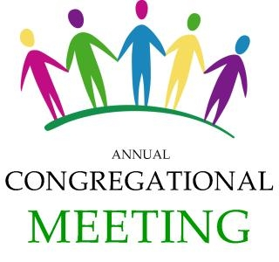
Please, bring my poinsettia to a shut-in______Yes________No

PLEASE put in the offering plate or return to the church office
by Sunday, December 22nd.

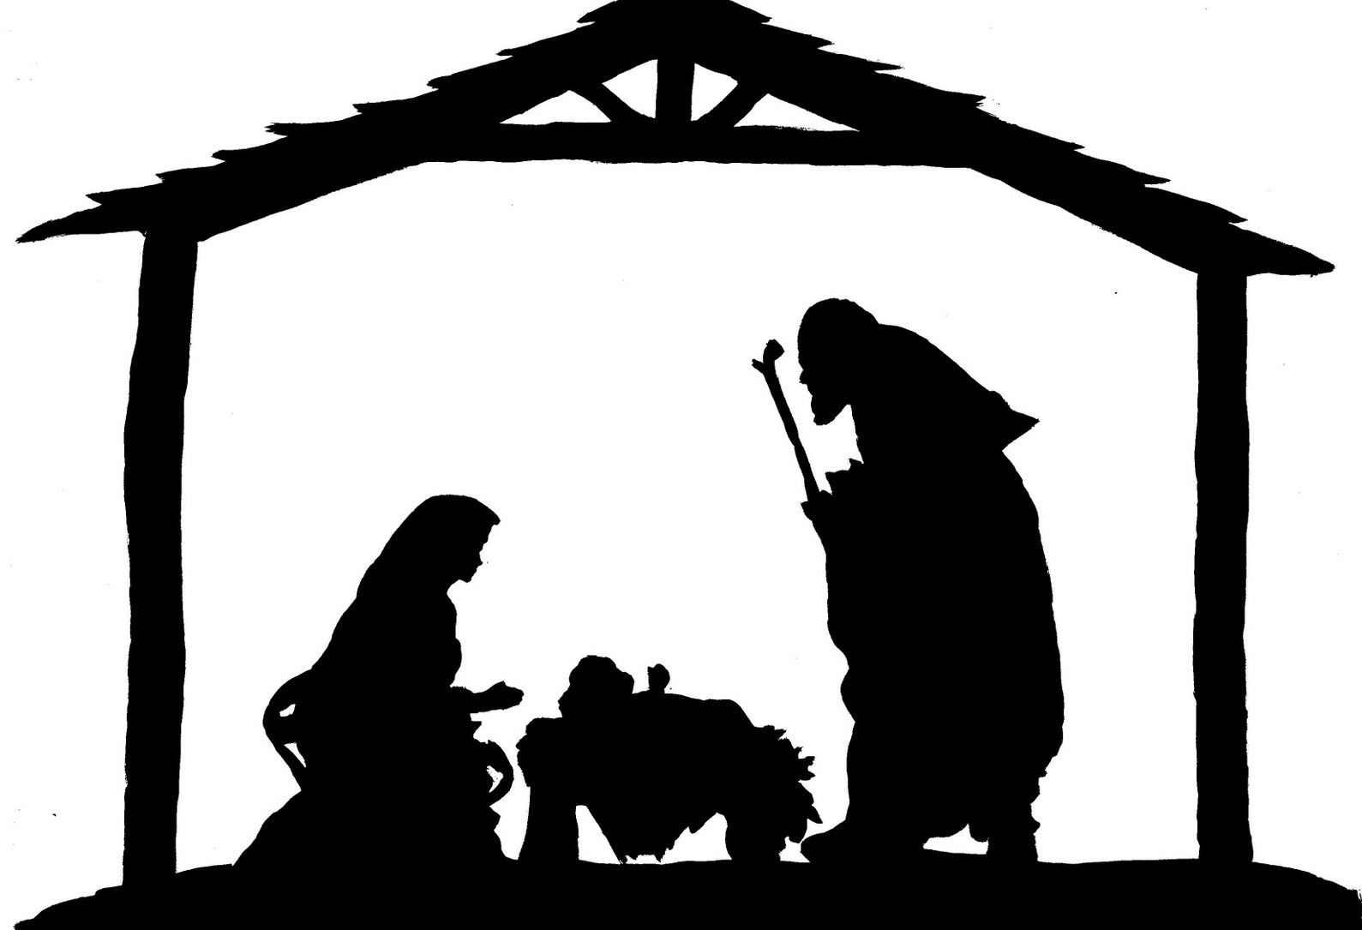
CHRISTMAS EVE WORSHIP SERVICE: Monday, December 24th, at a time to be determined.
Please watch future bulletins, Facebook, and the website for more information.



FOOD DONATIONS: Food will be collected for St. Vincent dePaul beginning November 3rd until Christmas. There is a box in the Narthex.

COUNCIL MEETING
Council Meetings will be November 10th and December 8th
following worship (11:15 a.m.)

WOW MEETING will be on Wednesday, December 11th
at 10:30 a.m.
Cookies will be packed for shut-ins and bachelors after the meeting.
A donation of 3 dozen cookies would be appreciated.

Annual Meeting: The Annual Meeting will be on Sunday, January 26th following worship.
A potluck dinner will follow the meeting.
Annual Report Deadline: Please have your Annual Reports turned in to the church office by January 8th.

